**Muhammad Umar Ahmadzai**

**03/17/2018**

**Purse by Reference**

**Problem Statement:**

The program is first going to ask the user to enter the number of pennies, nickels, dimes, and quarters to add to the purse, and then it is going to ask again for the number of pennies, nickels, dimes and quarters to delete. In the end it is going to output the result in dollars converting pennies, dimes, nickels, and quarters. It is also going to output the number of pennies, dimes, quarters, and dimes left.

**Input/Output Description:**

**Following are going to output types of filling:**

User is asked to enter the amount of pennies to add:

cout << " Please enter the amount of pennies to add:";

Amount will be stored below.

cin >> p1;

Amount is going to be outputted.

cout << "Left amount: " << p << endl << endl;

Same procedure is applied to nickles, dimes, quarters.

User is asked to enter the amount of pennies to remove:

cout << " Please enter the amount of pennies to remove:";

Amount will be stored below.

cin >> p1;

Amount is going to be outputted.

cout << "Left amount: " << p << endl << endl;

Same procedure is applied to nickles, dimes, quarters.

Amount of dollars will be outputted:

cout <<" You have total of: "<< dollars << "$." << endl;

Result will be displayed for pennies, dimes, quarters and dimes in the end:

cout << endl << endl << "This is the display section: " << endl << endl;

cout << "Total amount of Pennies: " << p << "." << endl;

cout << "Total amount of Nickles: " << n << "." << endl;

cout << "Total amount of Dimes: " << d << "." << endl;

cout << "Total amount of Quaters: " << q << "." << endl;

**Algorithm Development:**

Basically, we are creating different sections. Starting with initialization, insertion, removing, conversion, and displaying. We have created separate blocks for each one of them and assigned variables to input the amount to add and remove dimes, quarters, pennies, and nickels. Formula is being created for dollars conversion that will be done in conversion section. Lastly, that section will display the amount of pennies, quarters, dimes, and nickels left.

**Program Listing:**

#include <iostream>

using namespace std;

void initialize (int& p, int& q, int& n, int& d)

{

p=0;

q=0;

n=0;

d=0;

}

void insert(int& p, int& n, int& d, int& q)

{

int p1, q1, n1, d1;

cout << " Please enter the amount of pennies to add:";

cin >> p1;

p=p1+p;

cout << "Left amount: " << p << endl << endl;

cout << " Please enter the amount of nickles to add:";

cin >> n1;

n=n1+n;

cout << "Left amount: " << n << endl << endl;

cout << " Please enter the amount of dimes to add:";

cin >> d1;

d=d1+d;

cout << "Left amount: " << d << endl << endl;

cout << " Please enter the amount of quater to add:";

cin >> q1;

q=q1+q;

cout << "Left amount: " << q << endl << endl;

}

void remove (int& p, int& q, int& n, int& d)

{

int p2, q2, n2, d2;

cout <<"_____________________________________________________" << endl << endl;

cout << " Please enter the amount of pennies to remove:";

cin >> p2;

p=p-p2;

cout << "Left amount: " << p << endl << endl;

cout << " Please enter the amount of nickles to remove:";

cin >> n2;

n=n-n2;

cout << "Left amount: " << n << endl << endl;

cout << " Please enter the amount of dimes to remove:";

cin >> d2;

d=d-d2;

cout << "Left amount: " << d << endl << endl;

cout << " Please enter the amount of quater to remove:";

cin >> q2;

q=q-q2;

cout << "Left amount: " << q << endl << endl;

}

float dollars (int p,int n, int d,int q)

{

float dollars;

dollars= (p*0.01) + (n*0.05) + (d*0.10) + (q*0.25);

cout <<"_____________________________________________________" << endl << endl;

cout <<" You have total of: "<< dollars << "$." << endl;

}

int main()

{

int p,q,n,d;

initialize (p,q,n,d);

insert(p,q,n,d);

remove(p,q,n,d);

dollars(p,q,n,d);

cout << endl << endl << "This is the display section: " << endl << endl;

cout << "Total amount of Pennies: " << p << "." << endl;

cout << "Total amount of Nickles: " << n << "." << endl;

cout << "Total amount of Dimes: " << d << "." << endl;

cout << "Total amount of Quaters: " << q << "." << endl;

return 0;

}

**Sample test run of the program:**

Amount to add is inputted and amount to subtract. Following is the result in dollars and in pennies, quarters,

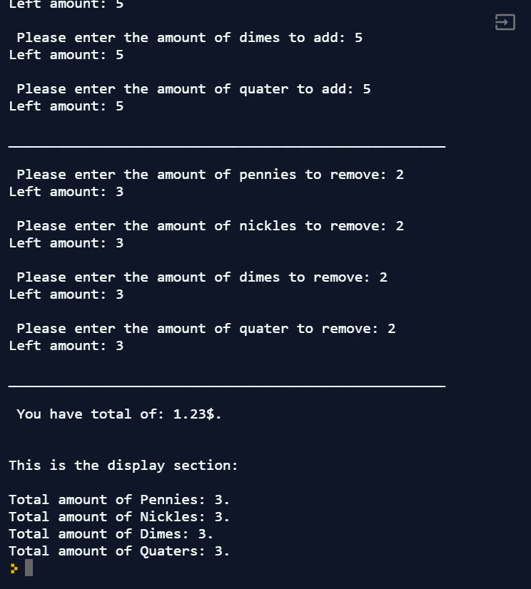

**Observation and Error Handling and general comments:**

Did not faced any errors.

**Conclusion:**

In conclusion, it will ask the user to add and removes dimes, quarters, nickels, and pennies. It will convert it to dollars and also display the left amount of pennies, dimes, quarters and nickels.